All Day
Throughout the school day, staff should do the following:
Clean and sanitize tables before and after eating. | Clean activity tables after use. | Clean visibly dirty surfaces and areas.
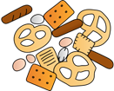 | 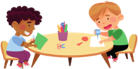 | 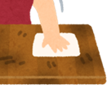
End of Day
At the end of the school day, staff should do the following :
Pick up debris, remove trash, and replace liners. Clean and disinfect trash containers. | 
Dust horizontal surfaces starting high and working lower. | 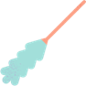
Clean and disinfect high-touch surfaces: doorknobs, light switches, computer keyboards, etc.
Clean and disinfect desktops, tables, countertops, and activity stations. | 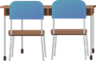
Clean and disinfect sinks, faucets, and drinking fountains. | 
Clean whiteboards. | 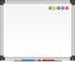
Clean floors--either sweep and mop or vacuum. | 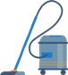
References
How To Clean and Disinfect Early Care and Education Settings
https://www.cdc.gov/hygiene/about/how-to-clean-and-disinfect-early-care-and-education-settings.html?CDC_AAref_Val=https://www.cdc.gov/hygiene/cleaning/early-care-education-settings.html
Schedule for Cleaning, Sanitizing, and Disinfecting
https://eclkc.ohs.acf.hhs.gov/publication/schedule-cleaning-sanitizing-disinfecting
Cleaning, Sanitizing, and Disinfection Frequency Table
https://www.naeyc.org/sites/default/files/globally-shared/downloads/PDFs/accreditation/early-learning/clean_table.pdf

