Check to see if a product is on List N
If you have a product but are not sure if it kills the germs that cause COVID-19, use the List N Tool to ensure it is effective against the virus.
Step | Action
1. | Access the List N Tool: COVID-19 Disinfectants. https://cfpub.epa.gov/wizards/disinfectants/.
2. | Click Launch.  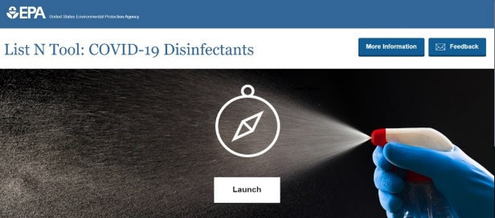
3. | Click # EPA Registration Number.  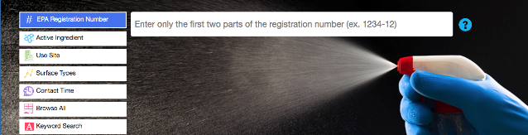
4. | Find the registration number on the product’s label.  Type the first 2 sections of the EPA registration number in the #EPA Registration Number field.  Example: If the number is 1234-12-1234, only enter 1234-12.  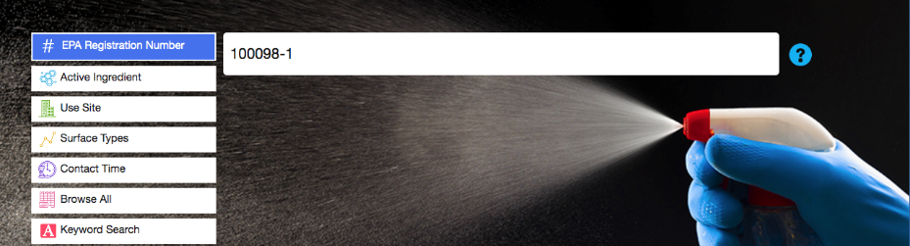
5. | Click Show results.
6. | Scroll down to see the results for your product. There is a chart that tells you:  - Active ingredients in the product  - Contact time (the amount of time the surface should remain wet to kill COVID-19)  - Formulation type (how to apply the product)  - Surface type (what surfaces it works on)  - Use site (locations where you can use the product)  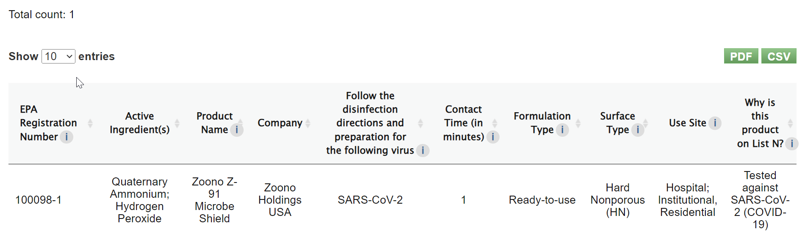

Find a product from List N
If you need to find a product that kills the germs that cause COVID-19, use the List N Tool.
Step | Action
1. | Access the List N Tool: COVID-19 Disinfectants. https://cfpub.epa.gov/wizards/disinfectants/.
2. | Click Launch.
3. | Click Use Site.
4. | Select Institutional.  Note: Schools are in this category.
5. | To filter your search, you can click Surface Types:  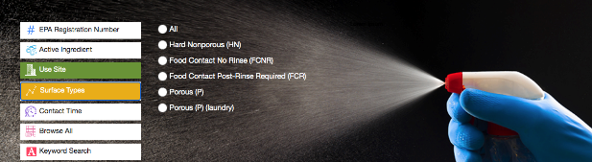
  Surface Type | Includes
  Hard Nonporous (HN) | Use on hard nonporous surfaces like doorknobs, faucets, light switches, stainless steel, and sealed wood.
  Food Contact No Rinse (FCNR) | Use on surfaces that touch food like countertops and refrigerators. Do not use on food. You do not need to rinse the surface after using this product.
  Food Contact Post Rinse Required | Use on surfaces that touch food like cutting boards, dishes, and cooking utensils. Do not use on food. Rinse the surface after using this product.
  Porous | Use on porous surfaces like fabric, cushions, untreated wood.
  Porous Laundry | Use on textiles or fabrics such as cotton, terrycloth, and microfiber. These surfaces can be thrown in the laundry.
6. | 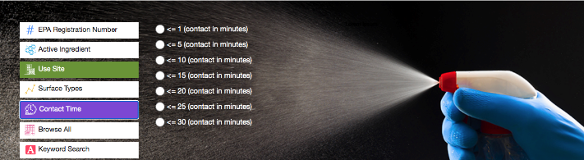  To further filter your search, you can click Contact Time:  A longer contact time means you may have to re-wet the surface with the product.  A shorter contact time means the product is faster acting, and you may not have to re-wet the surface.
7. | Click Show Results to view the registered products.

